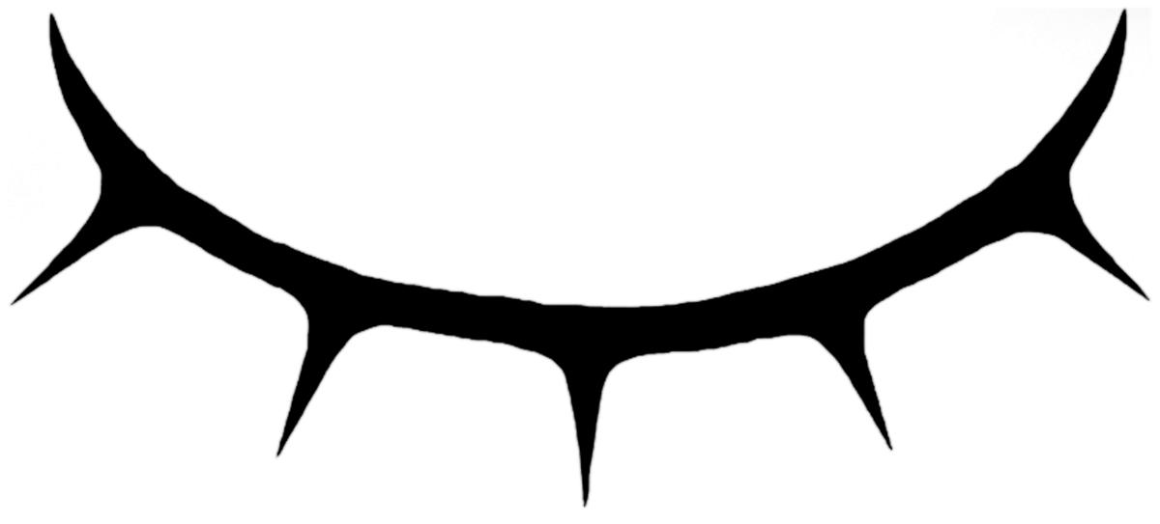
The Unseen Hour
A horror comedy podcast.
Performed monthly as live radio theatre in front of a living audience.

The Unseen Hour is both a live stage show and a podcast - an anthology fiction series with a new story each episode. Each episode also includes a monologue written by a guest writer and performed by a guest actor, and a live song from a musical guest.

All is not what it seems. Whether in medieval Mesopotamia, the trenches of The Somme, or an interstellar starship, there are always hidden depths, always dark convolutions that will emerge at The Unseen Hour.

Created and written by James Carney. this live radio theatre anthology series blends absurd comedy with genuinely unsettling horror and sci-fi concepts. The core cast consists of Carney and his long term collaborators Brice Stratford (Off West-End People’s Favourite 2012), Joey Timmins (Ogle Award winning radio series The Legend Of Springheel’d Jack) and Deborah Pearson (History, History, History). The podcast is produced by Andy Goddard (Wooden Overcoats).

The guest writers and performers have included writers Camilla Whitehill (Where Do Little Birds Go?) and Sam Thompson (Booker Nominated for Communion Town), performers Beth Eyre (Wooden Overcoats), Oliver Gully (The Mousetrap) and Rhiannon Neads (BBC Radio 4).

While The Unseen Hour is steeped in allusion and aims to be connected to both literature and pop-culture, it was initially created in response to a selection of American podcasts, specifically Welcome To Night Vale, The Thrilling Adventure Hour and Getting On With James Urbaniak. The intention was to bring a British attitude and sense of humour to this style of rapidly produced, ongoing comedy/drama. As such, The Unseen Hour emerges as something along the lines of Welcome To Night Vale meets The Goon Show, or Blackadder meets The Twilight Zone.

By its second episode The Unseen Hour was listed as New & Noteworthy on iTunes.

LIVE SHOWS
8pm, on the first Wednesday of every month.
7 June, 5 July, 2 August, 6 September
The Rosemary Branch Theatre, 2 Shepperton Road, London N1 3DT
All press and industry welcome.

THE UNSEEN HOUR
Starring Brice Stratford, Joey Timmins, Deborah Pearson and James Carney
Written, Directed and Produced by James Carney
Featuring a different guest writer, guest performer, and guest musician each episode
Podcast produced by Andy Goddard
Music by The Unrecorded

The first episode was released on the 19th of March 2017. A new episode has been released every two weeks thereafter.

More information
james@unseenhour.com
James Carney - 07540 953 600
www.unseenhour.com
@UnseenHour

Production Photos
Higher resolution images available on demand.

